Pokhara University

Level: Bachelor | Semester – Fall | Year : 2009
Programme: B.E. |  | Full Marks : 100
Course: Applied Mechanics I |  | Time : 3hrs.

Candidates are required to give their answers in their own words as far as practicable.
The figures in the margin indicate full marks.

Attempt all the questions.

1. | Describe free body diagram.  Three cables are used to support a container as shown. Determine the angle formed by cable AC and AD.  x  y  450 mm  650 mm  700 mm  z  D  C  B  A  O  600 mm  1125 mm | 5+10
2. | Describe angle of friction with neat sketch?  Determine the smallest force P for which equilibrium of the 7.5 kg block is maintained.  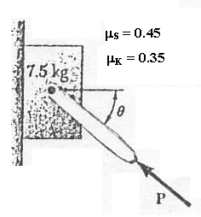 | 5+10
3. | - Determine by direct integration the moment of inertia of the shaded area with respect to the x axis and y axis respectively.  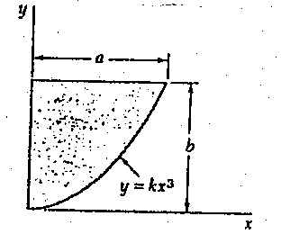  - (b) Locate the centroid given figure.  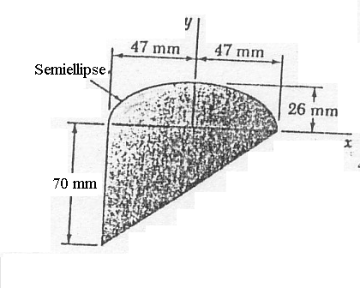 | 7  8
4. | Describe the condition of equilibrium in three dimension structure?  A concrete foundation mat of 5 m radius supports four equally spaced columns, each of which is loaded 3.5 m from the center of the mat. Determine the magnitude and the point of application of the resultant of the four loads.  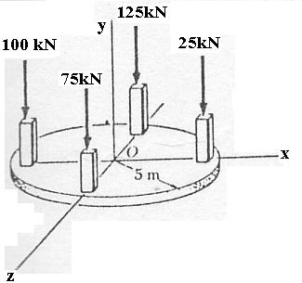 | 5+10
5. | Analysis the given truss by method of joints.  30KN  20 KN  3 m  3 m  60⁰  60⁰  20 KN  45⁰ | 15
6. | Draw shear force and bending moment diagram of given beam.  2 m  2 m  2 m  4 m  5 KN/M  10 KN  10 KN  2 m | 15
7. | Write short notes on (Any Two)  - Parallel axis theorem  - Moment about Z-axis  - Radius of gyration | 5x2

